Weyerhaeuser Company Financial Overview
Student Name
Professor’s Name
Institution

Table of Contents
Introduction 3
Financial ratios; 3
Quick ratio 4
ROA 4
Asset turnover 5
Inventory turnover 6
Statement of cash flow 6
Balance sheet 6
Income statement 7
Conclusion 7
References 8
Appendices 9
Appendix I: Statement of Cash Flows 9
Appendix II: Balance Sheet 11
Appendix III: Income Statement 13

Introduction
Weyerhaeuster Company is an American timberland company owning about 12.4 million acres of timberlands in America and managing an additional 14 million acres of forests in Canada. The company started in the 1900 under Fredrick Weyerhaeuser (the founder) and managing only 900,000 acres of timberland in Tacoma Washington DC. This paper includes a financial and analysis.
Owners’ equity; this company is made up of institutional investors who hold majority ownership of WY via the 78.99 percent of the outstanding shares they control. Mutual fund holders constitute 48.51 percent of equity, 1.56 percent individual stakeholder, and other institutional investors earn 30.48 percent.

Financial ratios;
These are generally ratios that use selected values of a firm’s financial statements. In finance, there are many standard financial ratios used to evaluate the business or entity. These ratios are utilized by managers, other stakeholders for making certain decisions, used by business owners, and creditors of the same. It is important to note that financial ratios help both current and prospective investors. Additionally, security analysts use these ratios to make comparisons of the strengths and weaknesses of companies of interest. Many analytics want financial ratios categorized into the financial aspect that the ratio is measuring for example, growth ratios measuring the company’s growth rate and assess the prospective future growth e.g. net sales growth and EBIT Growth. Profitability ratio gauge the returns that the entity generates on sales and investments e.g. profit margin, operating margin, return on assets, return on equity, etc. Other ratios are classified as liquidity ratios and capital structure while others are considered efficiency and activity ratios.

Quick ratio
A ratio that measures the ability of a company to settle its short-term liabilities or financial claims using its most liquid assets such as available cash and cash equivalents. This ratio is computed by taking the total current assets minus total inventories and then dividing the result to by the total current liabilities. This company in discussion ha a quick ratio of 1.19 which implies a good short-term financial strength.
Quick Ratio (A: Dec. 2019) = (Total Current Assets - Total Inventories) /Total Current Liabilities
= (1611 - 416) /1006
= 1.19

ROA
This ratio measures the rate of return on total assets. It is a kind of an efficiency ratio since it measures the efficiency of generating profits from the equity and liabilities. It indicates how well a company utilizes its generated earnings. ROA is calculated by diving net income to its total assets. Weyerhaeuster’s annualized net income for 2019’s last quarter was -$56m and its average total assets of the same period were $16,619m. Its ROA, therefore, is computed as;
ROA % = Net Income (A: Dec. 2019) / ((Total Assets (A: Dec. 2018) + Total Assets (A: Dec. 2019)) / count)
= -76 / ((17249 + 16406) / 2)
= -76 /16827.5
= -0.45 %. This is the smallest that the company has ever realized in its history.

Asset turnover
A ratio that measures how quickly a company can turn over its assets via sales. It is calculated by taking revenue and dividing it by the total assets. For this company, the latter from the recent 10k report is as show below;
Asset Turnover
= Revenue / Average Total Assets
= Revenue (A: Dec. 2019) / ((Total Assets (A: Dec. 2018) + Total Assets (A: Dec. 2019)) / count)
= 6554 / ((17249 + 16406) / 2)
= 6554 / 16827.5
= 0.39
This is a reasonable asset turnover ratio that is associated with good profits.

Inventory turnover
Day’s inventory indicates the number of days goods remain unsold in the company’s inventory. It measures how soon a firm turns over its inventory in a given year. Calculated as cogs divide by total inventories.
= CoGs Sold /Total Inventories
= CoGs (A: Dec. 2019) / ((Total Inventories (A: Dec. 2018) + Total Inventories (A: Dec. 2019)) / count)
= 5412 / ((389 + 416) / 2)
= 5412 / 402.5
= 13.45

Statement of cash flow
The disparities begin indicating right from the top where net income for the 2019 financial year is significantly low. (Its negative by a huge value as a matter of fact). Attached below is a figure of the statement of cash flow.

Balance sheet
Looking at WY’s 2019 balance sheet, the company’s performance seem to have degraded in the year compared to the 2018, 2017, 2016, etc. For instance, the company’s 2019 total assets were $16,406,000,000, a reduced figure from the previous years. In 2018, 2017, and 2016 the same was $ 17,249,000,000, 18,059,000,000, and 19,243,000,000 respectively. The reason behind this and that is noticeable in the balance sheet is the zero equity and other investments for this particular year. This had a big impact on the balance sheet of the company. The liabilities of the company were slightly high for the 2019 year and this was as a result of a slight increase in long term debt and other long-term liabilities.

Income statement
The company’s total revenue for the year 2019 was less than that of 2018. Gross profit significantly reduced perpetuating such changes in the income statement. Also selling and administrative expenses increased this particular year than they were the previous even with seemingly less operations. The decrease in EBITDA was huge, in 2019 it was registered as $675,000,000 from 2018’s $1,668,000,000. This resulted in a net income of -76,000,000 from 2018’s net income of $748,000,000.

Conclusion
Weyerhaeuser Company is a good investment option considering its performance over the past few years. The 2019 financial year seems to have been bad for the company but nevertheless, it is copying. Insightful investors need to stake their investments with the company because it anticipates a greater future.

References
Home : Weyerhaeuser. (2019). Retrieved from Weyerhaeuser.com website: https://www.weyerhaeuser.com/
The Complete Toolbox for Investors | finbox.com. (n.d.). Retrieved April 28, 2020, from finbox.com website: https://finbox.com/NYSE:WY/explorer/quick_ratio
Weyerhaeuser Company (WY) Cash Flow - Yahoo Finance - Yahoo Finance. (n.d.). Retrieved April 27, 2020, from finance.yahoo.com website: https://finance.yahoo.com/quote/WY/cash-flow?p=WY
Weyerhaeuser Company (WY) Stock Price, Quote, History & News - Yahoo Finance. (n.d.). Retrieved April 27, 2020, from finance.yahoo.com website: https://finance.yahoo.com/quote/WY/

Appendices

Appendix I: Statement of Cash Flows
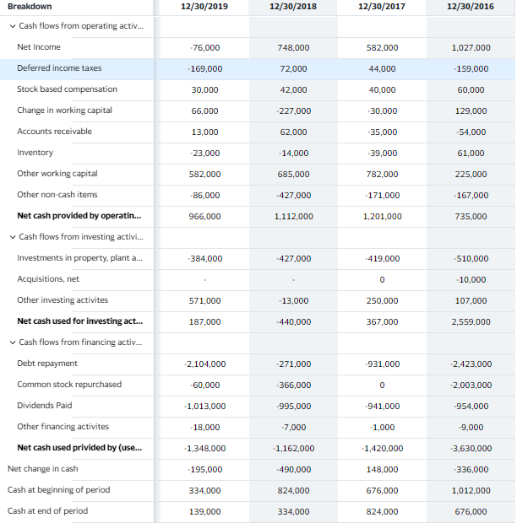
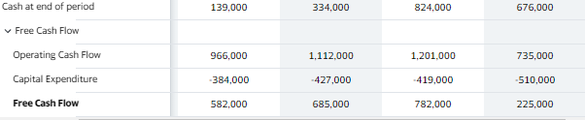

Appendix II: Balance Sheet
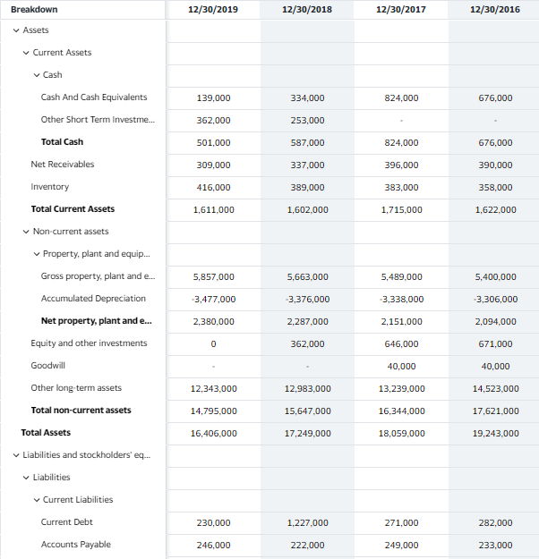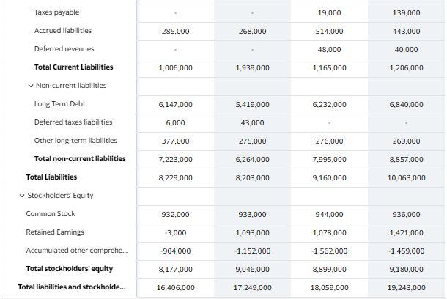

Appendix III: Income Statement

